**Heart Disease Detection**

* **Project Title:**

Heart diseases Detection

(Early Detection of Heart Disease using Artificial Intelligence)

* **Introduction:**

Heart disease is a major cause of mortality worldwide, accounting for millions of deaths each year. Early detection of heart disease is critical for effective treatment and management. While several diagnostic tools and risk assessment models are available, the accuracy and reliability of these methods vary widely. Artificial intelligence (AI) has emerged as a powerful tool for medical diagnosis and risk prediction, and this project aims to develop an AI model for the early detection of heart disease.

* **Objectives:**

The primary objective of this project is to develop an AI model that can accurately predict the risk of heart disease in patients based on their medical history and lifestyle factors. Specifically, the project aims to:

1. Collect and preprocess a large dataset of patient health records, including medical history, lifestyle factors, and lab test results.
2. Develop and train an AI model using deep learning algorithms to predict the risk of heart disease in patients.
3. Evaluate the performance of the AI model using standard evaluation metrics and compare it with existing risk prediction models.
4. Develop a user-friendly interface for healthcare professionals to access and utilize the AI model.

* **Methodology:**

The project will follow the following methodology:

1. **Data Collection:**

We have all these resources to collect a large dataset of patient health records from multiple sources, including electronic health records (EHRs), medical insurance claims, and publicly available datasets. We will get dataset from Kaggle.

1. **Data Preprocessing:**

The collected data will be preprocessed to remove missing values, outliers, and inconsistencies. The data will be normalized and standardized to ensure compatibility with the machine learning algorithms.

1. **AI Model Development:**

We will use machine learning algorithms, such as SVM, LinearRegression and RandomForest to develop the AI model for heart disease risk prediction. We will also use transfer learning to leverage pre-trained models on related medical datasets.

1. **Model Evaluation:**

The performance of the AI model will be evaluated using standard evaluation metrics such as sensitivity, specificity, accuracy, and F1 score. We will also compare the performance of the AI model with existing risk prediction models.

1. **User Interface Development:**

We will develop a user-friendly interface for healthcare professionals to access and utilize the AI model. The interface will allow healthcare professionals to input patient data and receive the AI-generated risk prediction.

* **Expected Results:**

We expect that the AI model will be able to accurately predict the risk of heart disease in patients with a high degree of accuracy, which will enable early detection and treatment of the disease, potentially saving many lives. The developed model could also improve the efficiency and accuracy of heart disease diagnosis and risk prediction in clinical practice.

* **Description:**

Heart disease is very dangerous for people of any age. Lot's of people are dying every year due to heart diseases. If someone with heart disease follow proper rules and regulation he might live ok. So the important part is to determine if someone has heart disease or not. In this project we are going to do exactly this.

* **Steps:**

1. Understanding the problem

2. EDA

3. Data preprocessing

4. Modeling

5. Evaluation

By this AI Project we have to save the life of people.

* **Attributes that used in this project:**

1. Age
2. Sex
3. Chest Pain
4. Resting blood Pressure(BP)
5. Cholesterol
6. Fasting BS
7. Resting ESG
8. Max heart rate(HR)
9. Exercise angina
10. Old peak
11. ST slope
12. Heart Disease

* **Conclusion:**

This project aims to develop an AI model for the early detection of heart disease, which could improve the accuracy and efficiency of heart disease diagnosis and risk prediction. The project is expected to deliver an AI model that can accurately predict the risk of heart disease in patients with a high degree of accuracy, potentially saving many lives.

* **Front End Of Project:**

I have develop the front end on **Spyder** by using **Streamlit** and **Pickle-mixin** in the terminal of spyder.

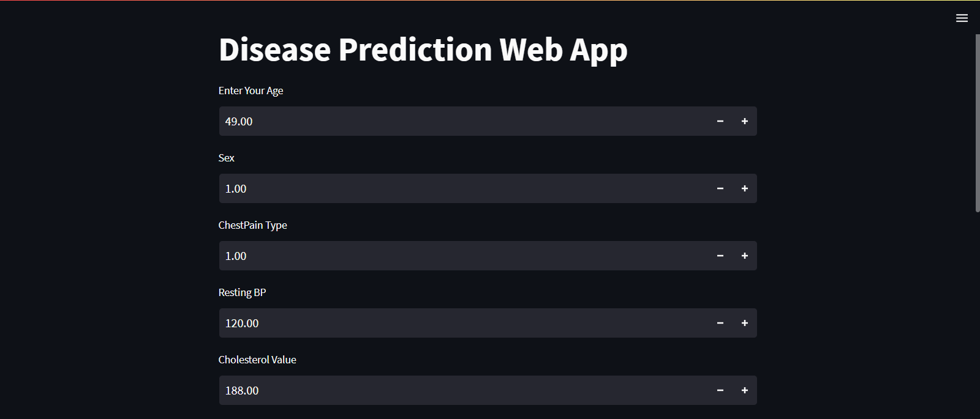

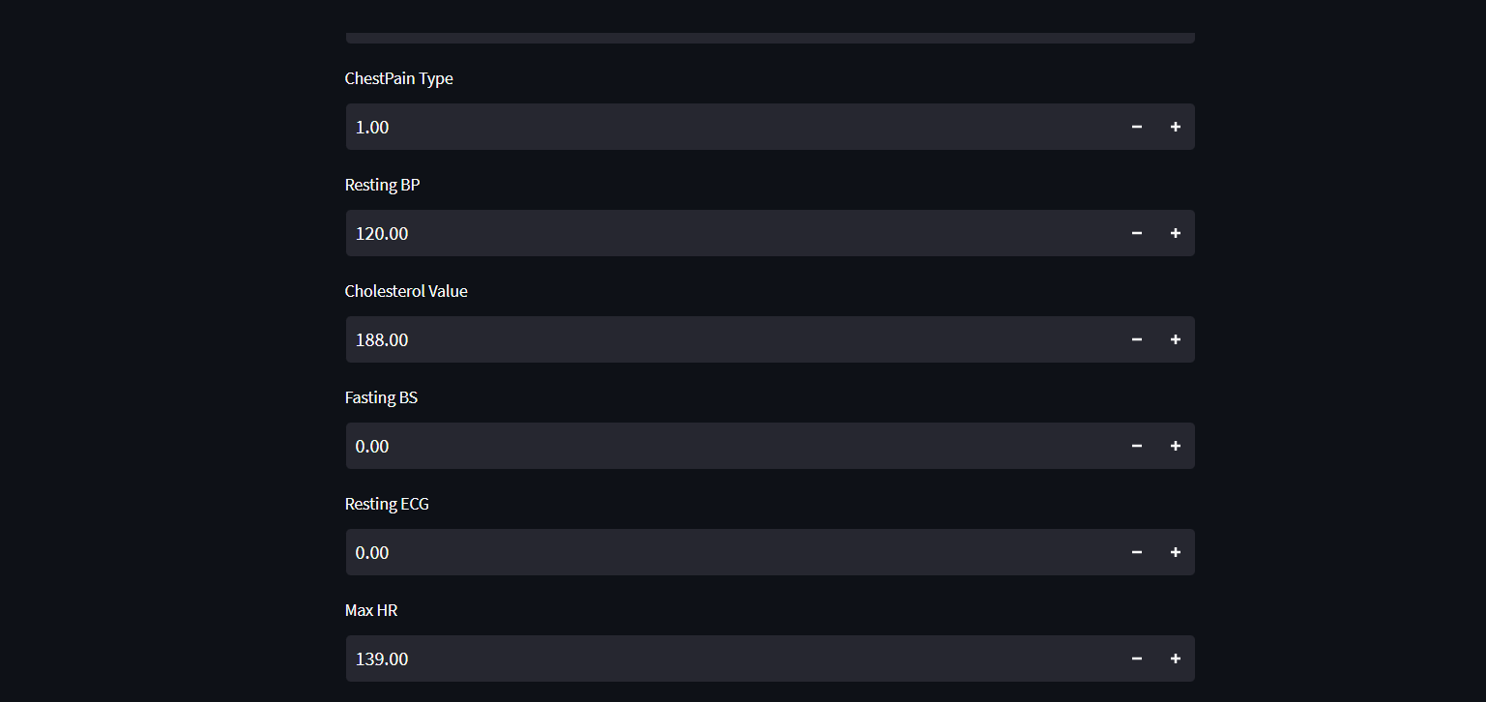



* **Spyder Code:**

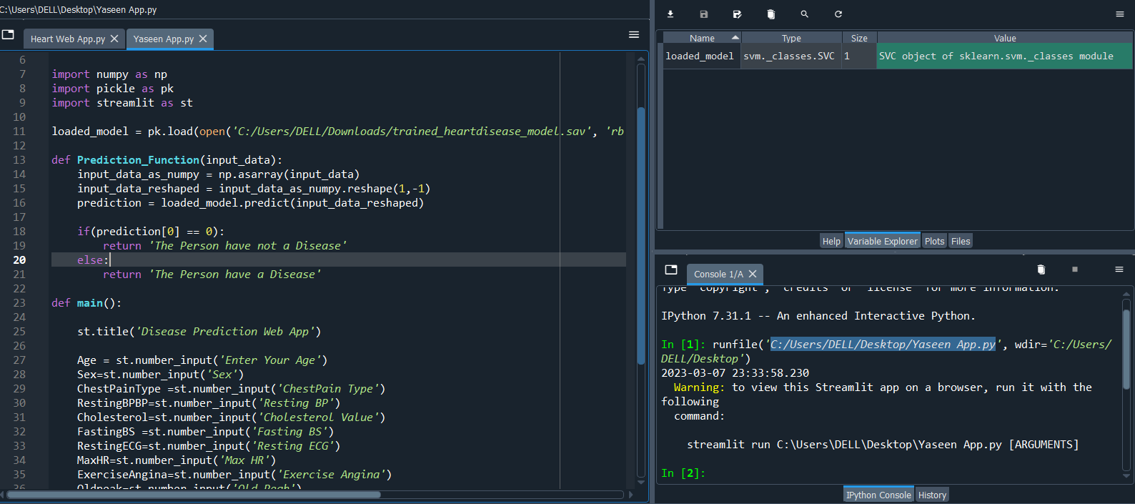

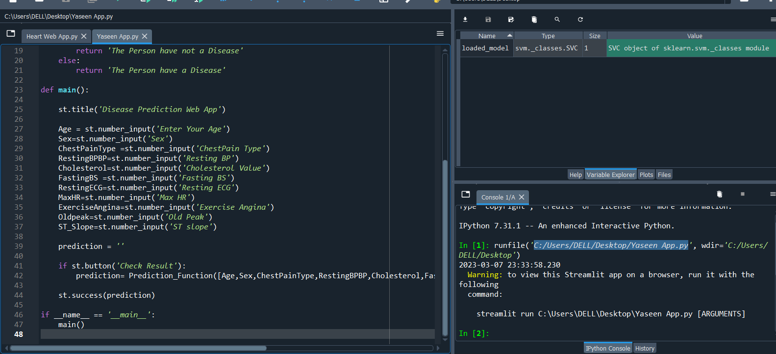

* **Back End Code on Jupiter Notebook:**

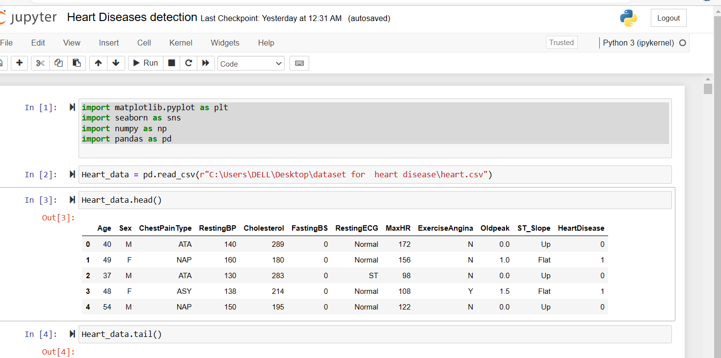

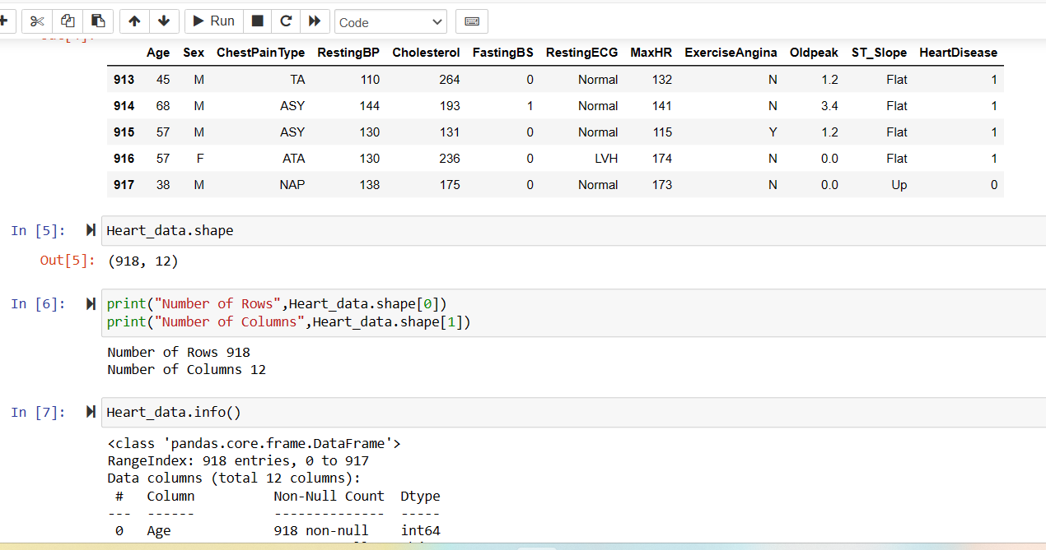

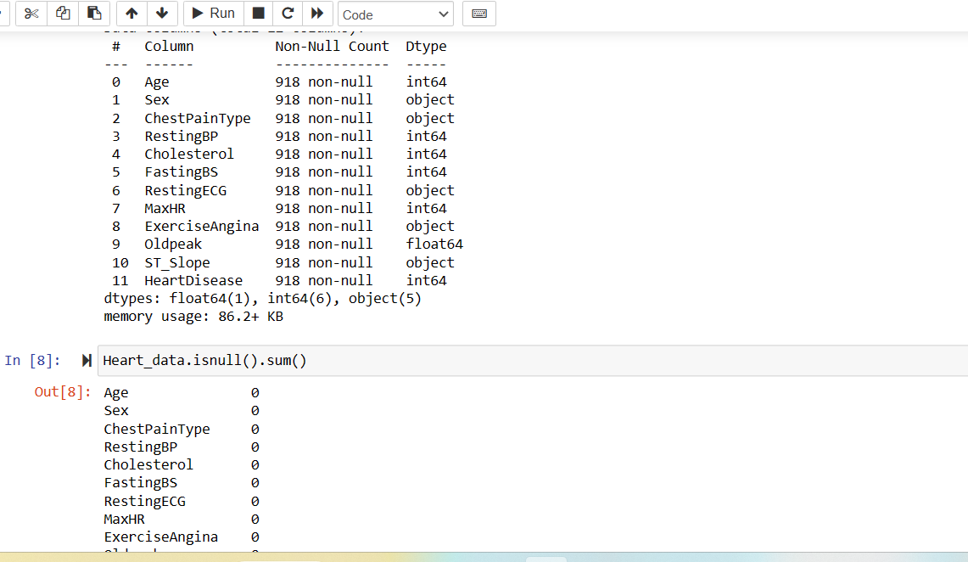

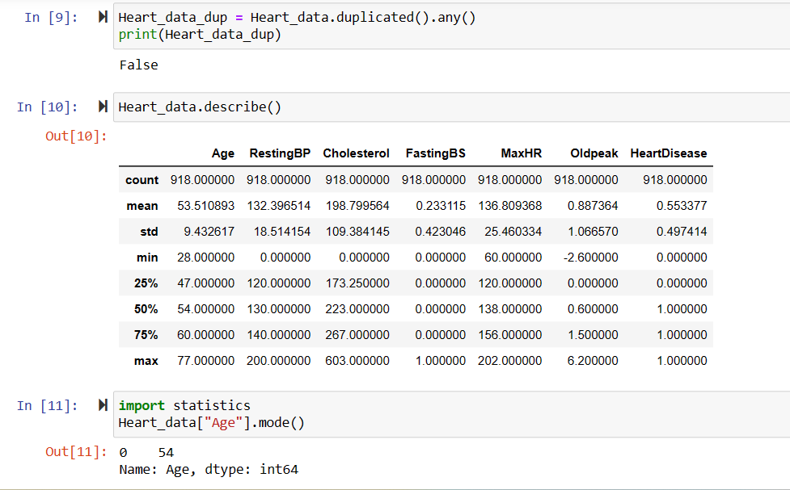

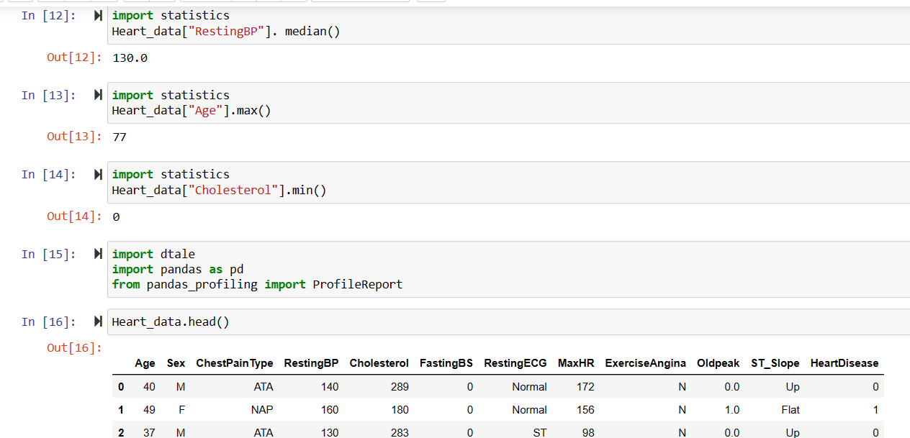

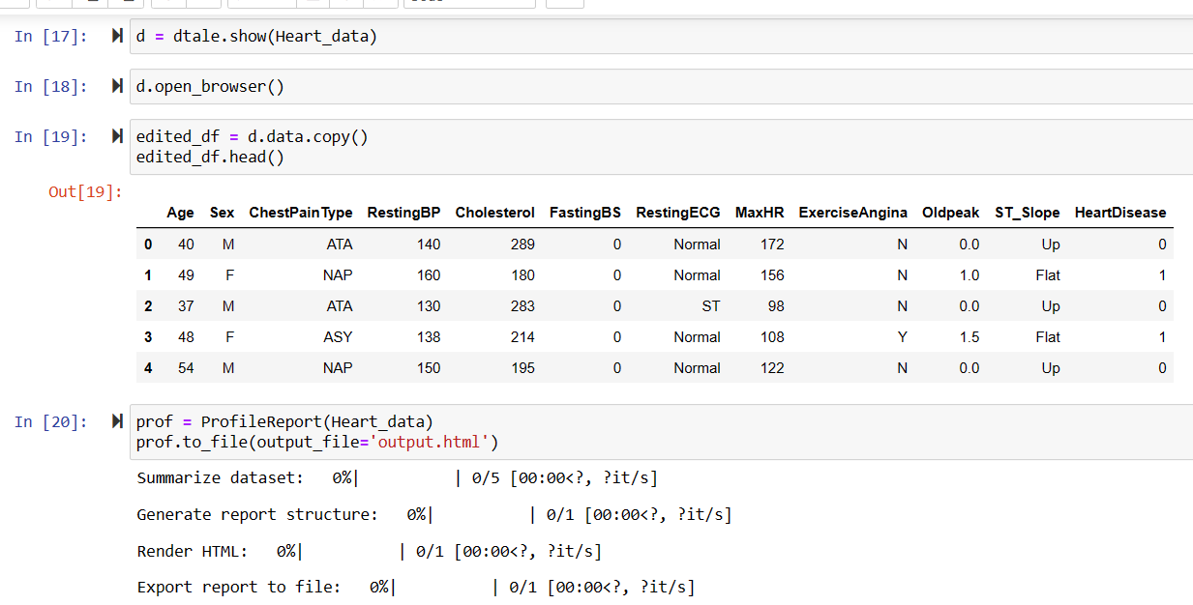

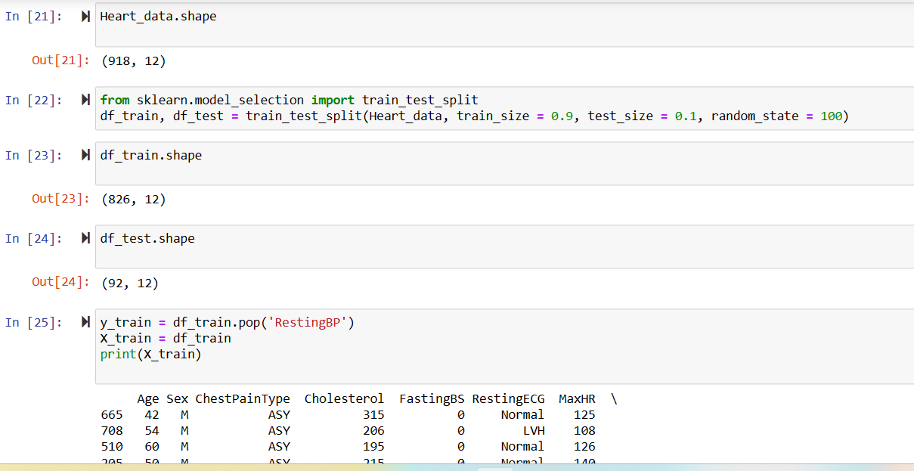

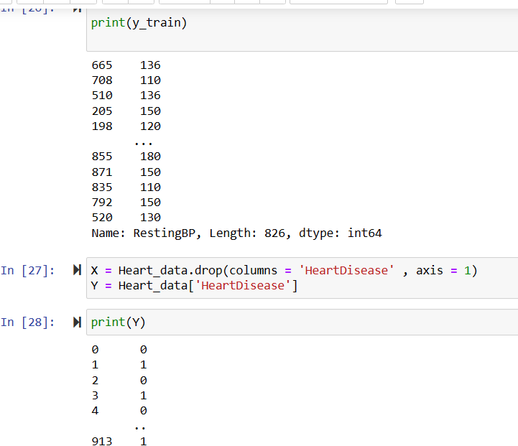

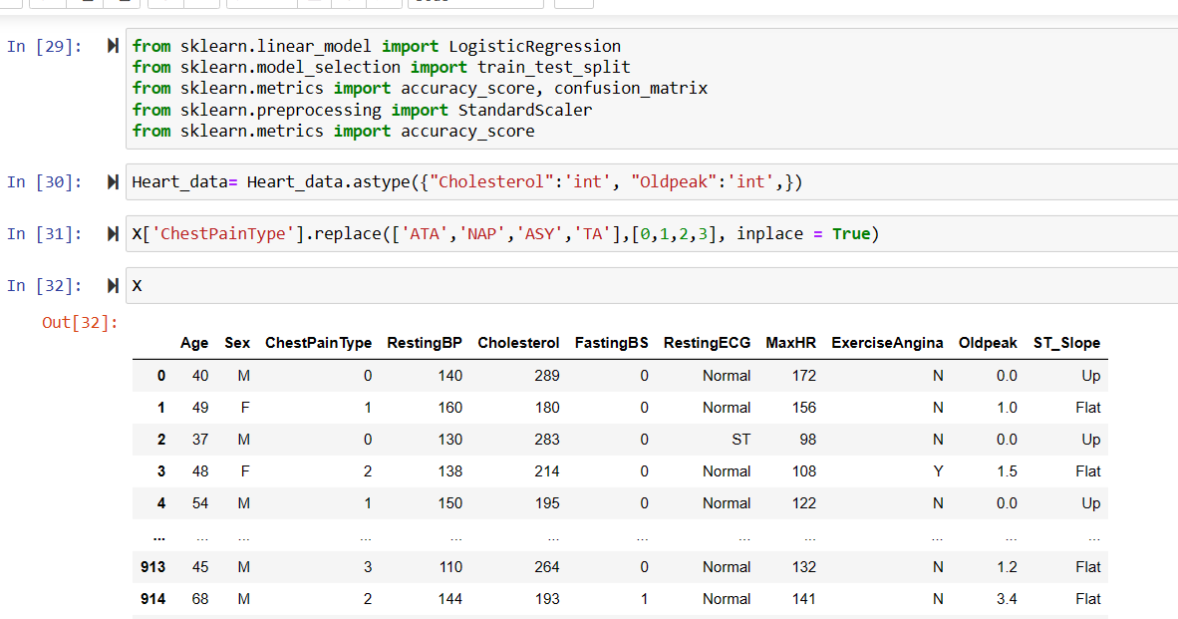

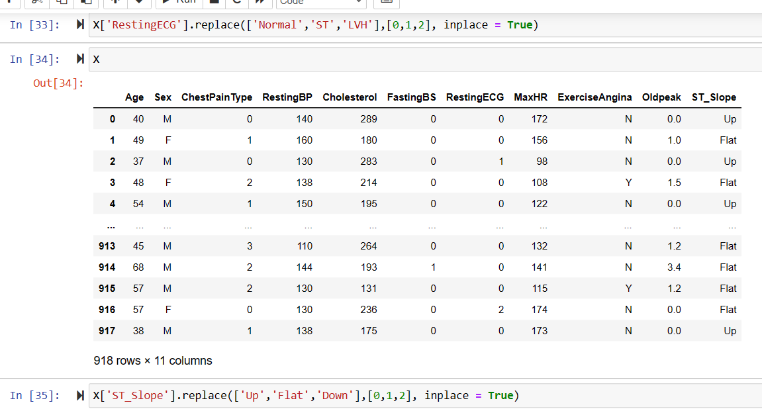

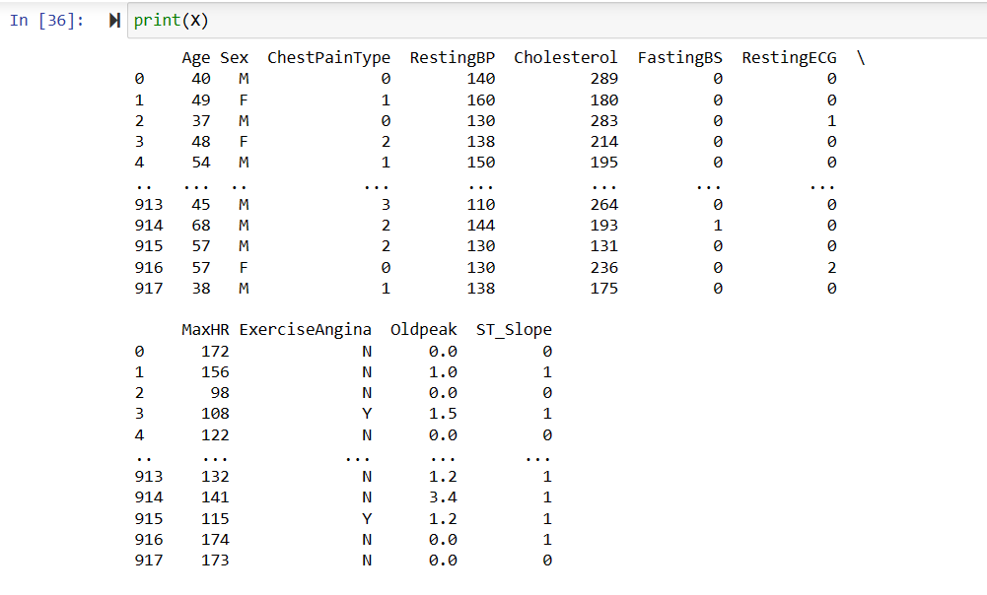

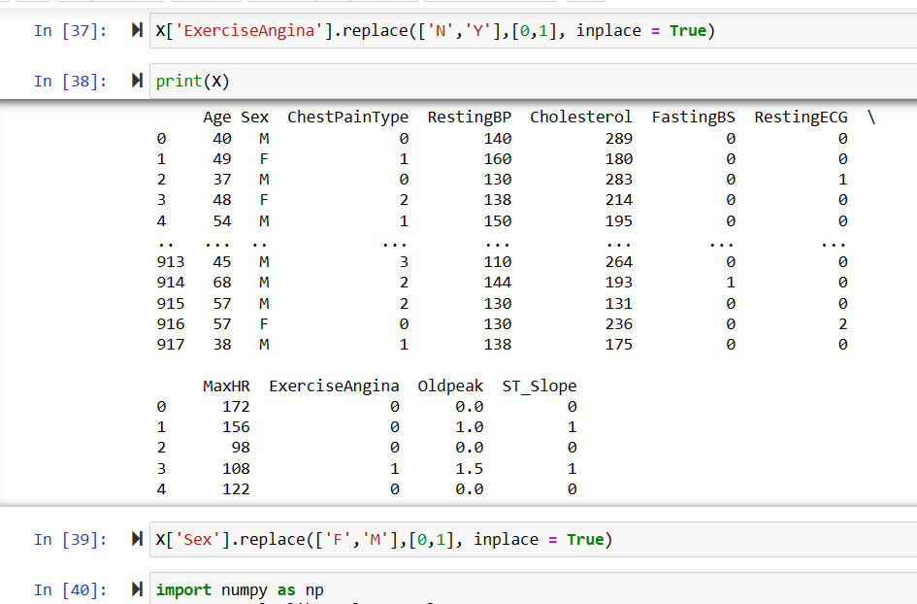

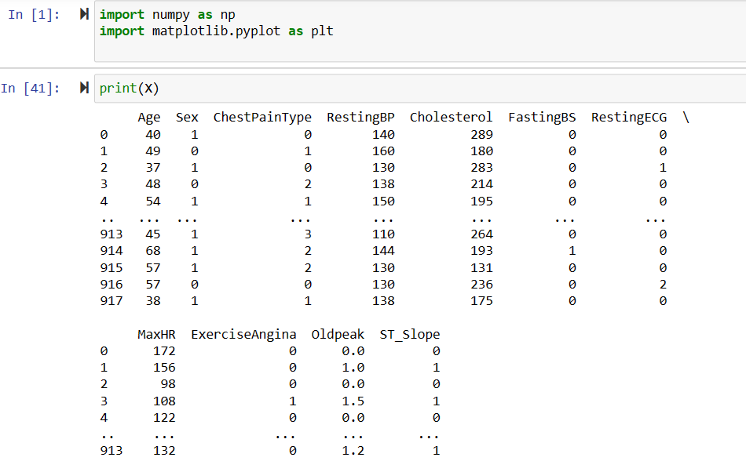

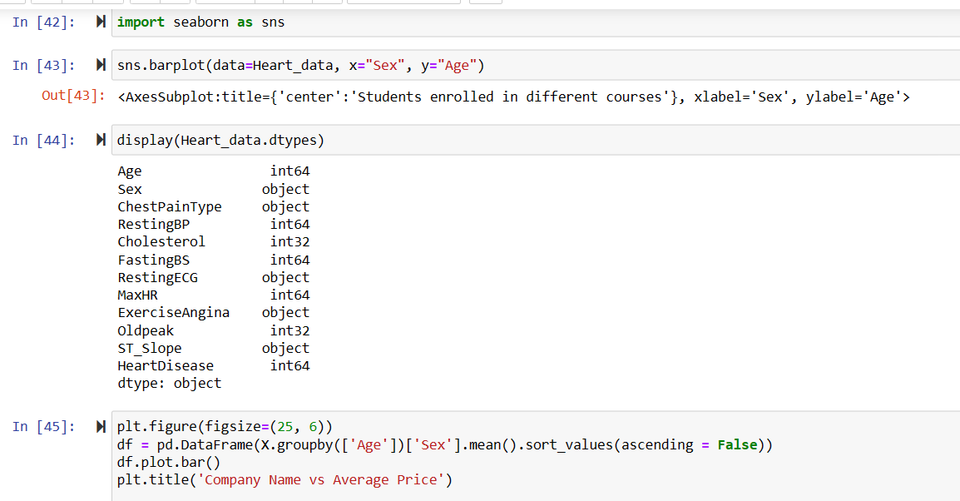

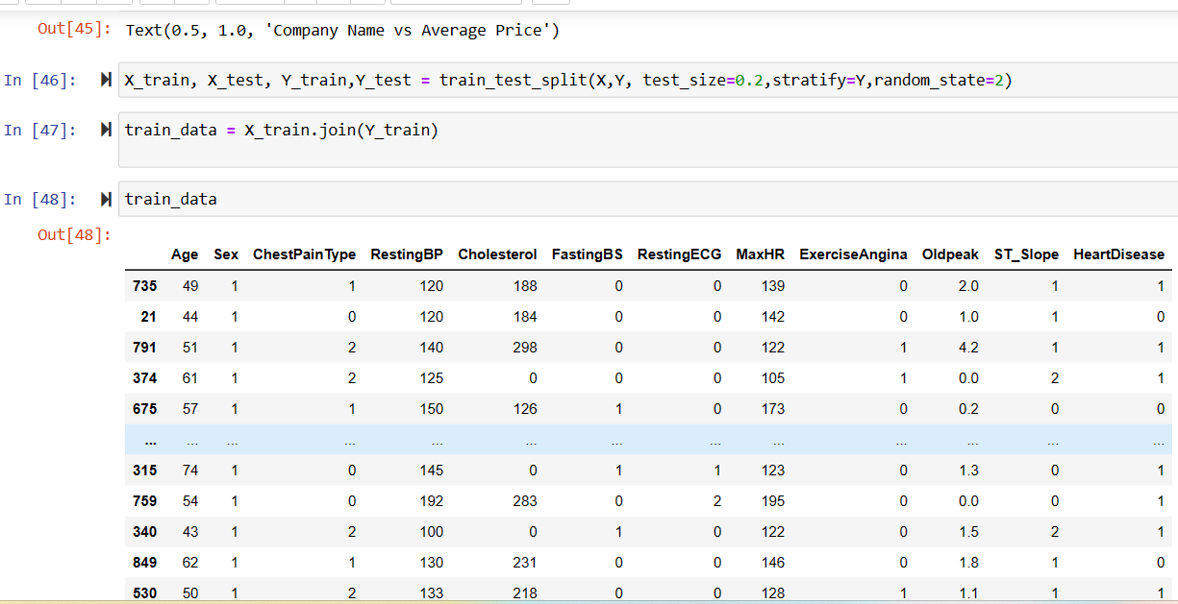

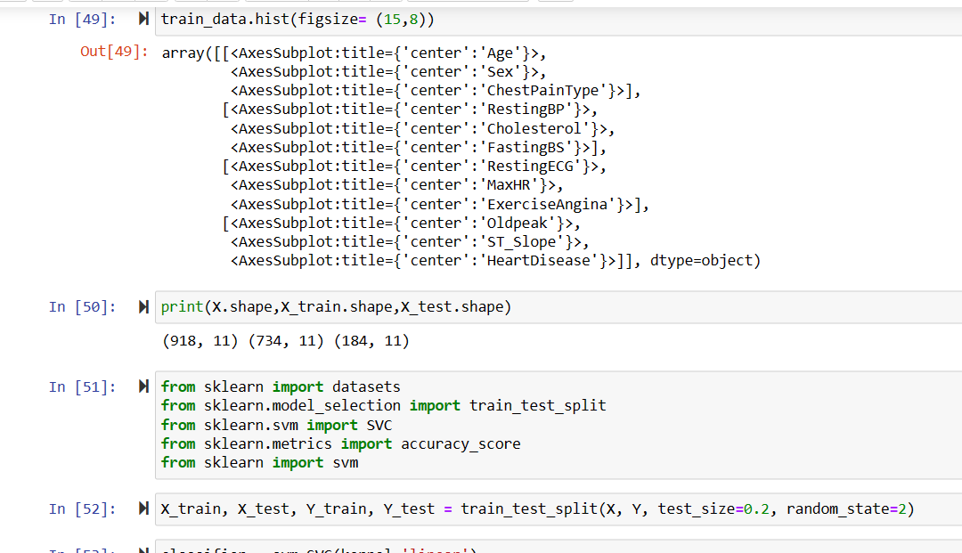

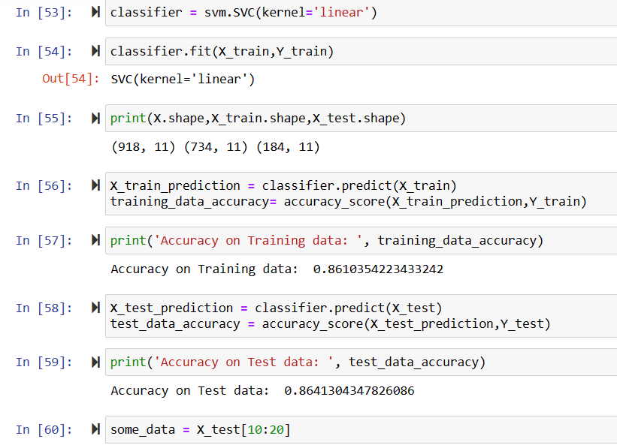

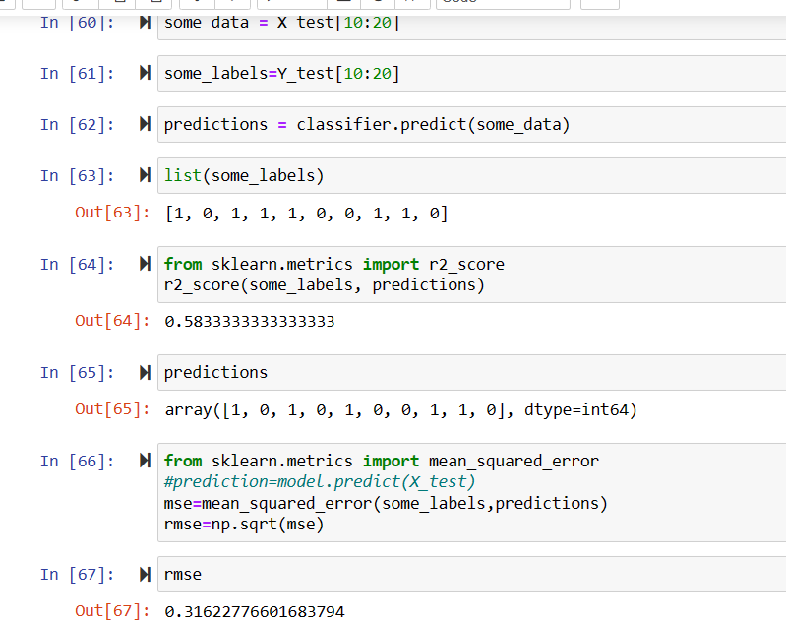

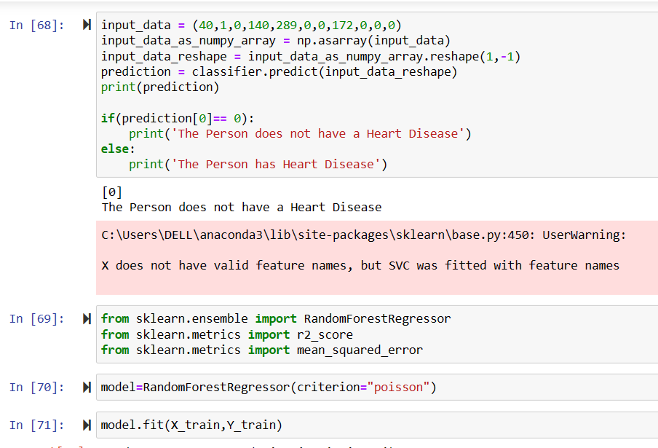

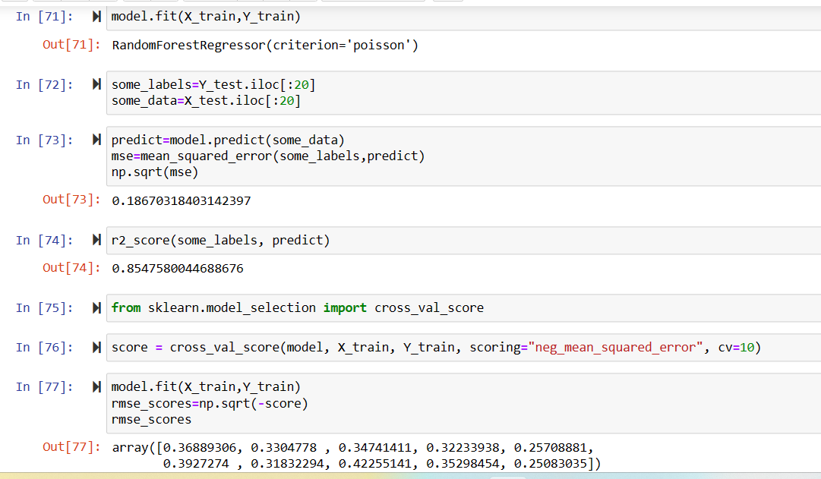

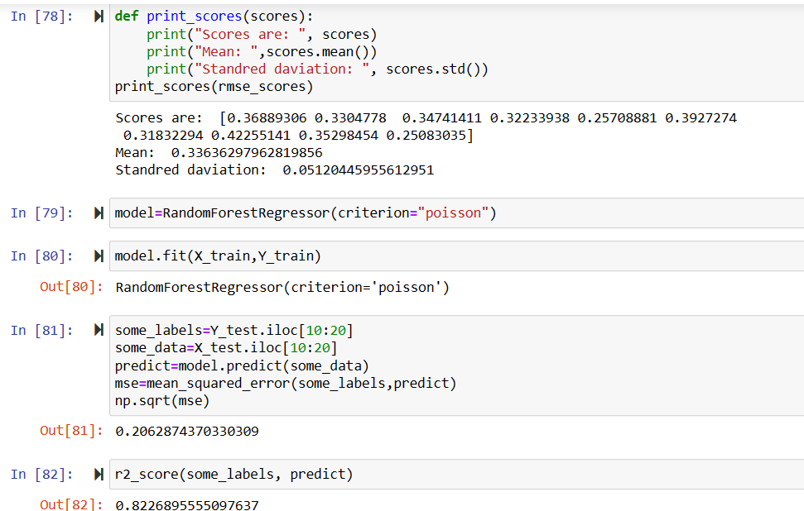

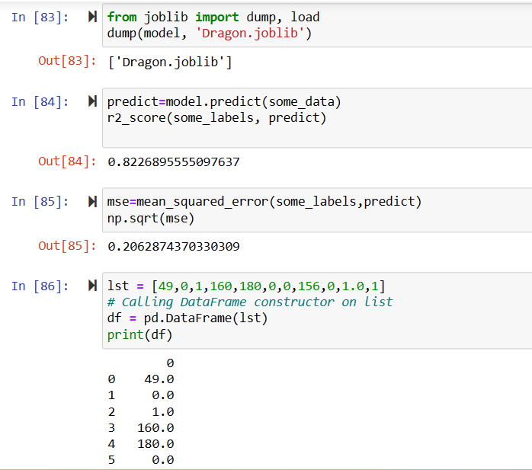

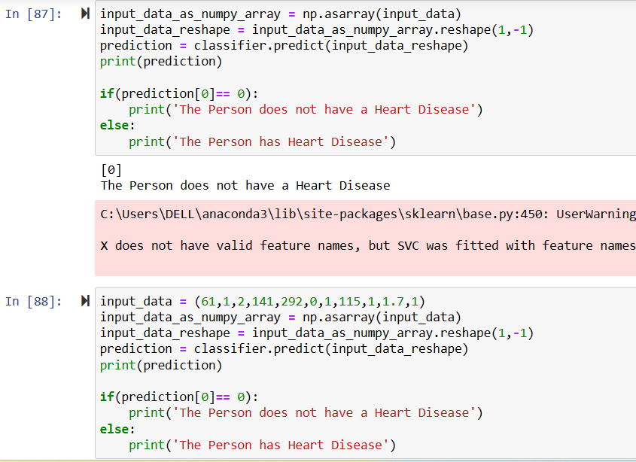

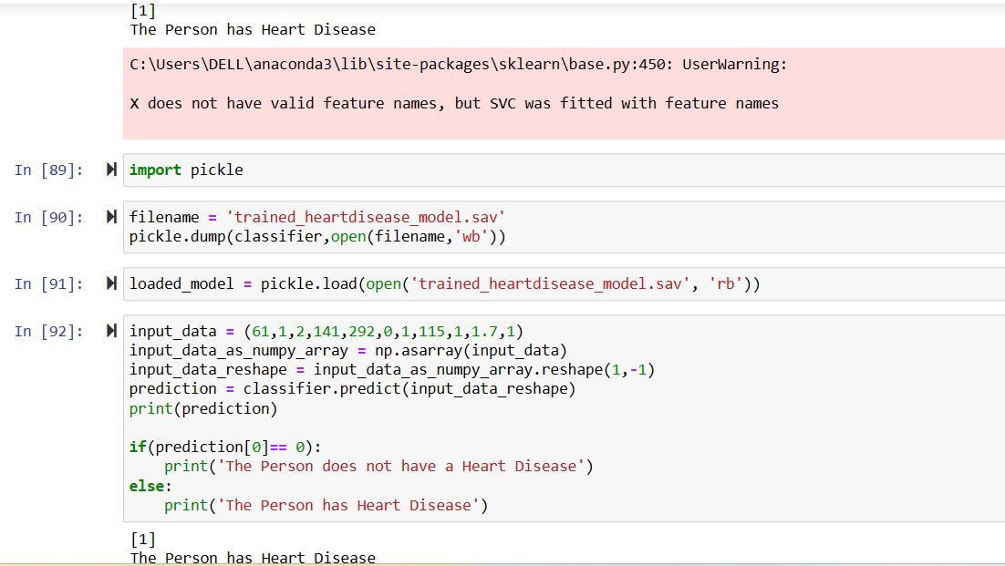

* **DataSet:**

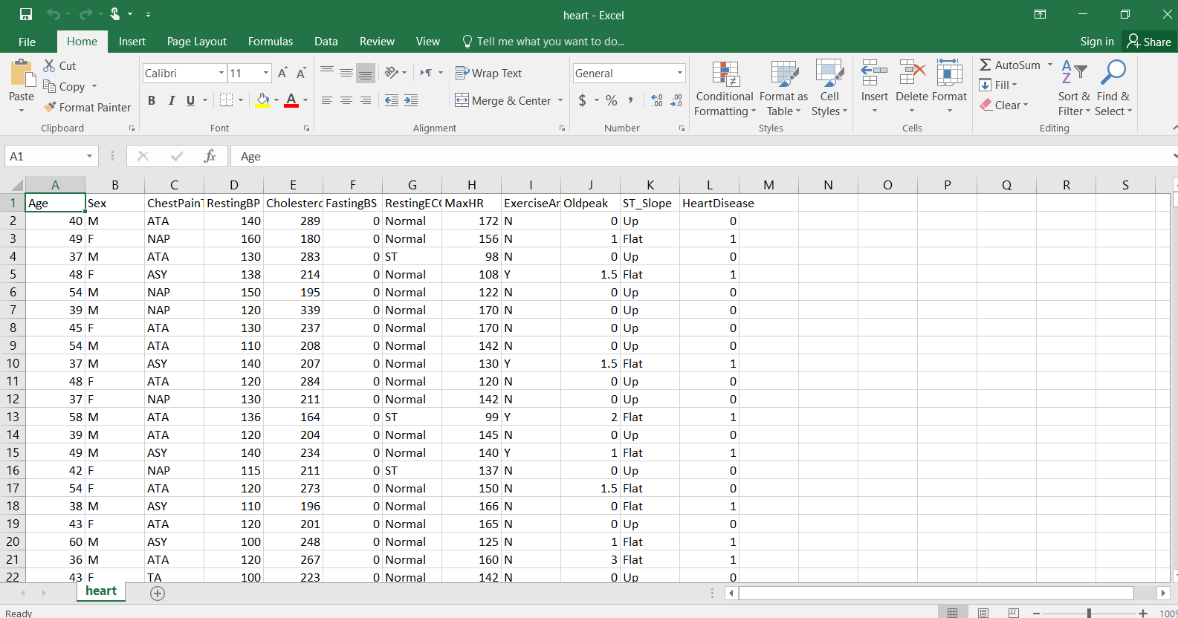

* **Conclusion:**

This project aims to develop an AI model for the early detection of heart disease, which could improve the accuracy and efficiency of heart disease diagnosis and risk prediction. The project is expected to deliver an AI model that can accurately predict the risk of heart disease in patients with a high degree of accuracy, potentially saving many lives.

**Thank u So Much**